Discussion Brief: STAP in GEF-6

INTRODUCTION

1. This brief is based on a number of documents assessing and recommending how the GEF can improve the delivery of global environmental outcomes, and how STAP could support the GEF in this process. The documents include the following:

- GEF EO Fifth Overall Performance Evaluation or OPS5 (incl. Technical Documents 10: Sub-study on Results Based Management in GEF; 11: Knowledge Management in the GEF; 15: Evaluation of the STAP of the GEF);
- GEF/STAP/C.43/Inf.02: Research within the GEF: Proposals for revising the targeted research modality;
- GEF/R.6/Inf.03: Enhancing the GEF’s contribution to sustainable development;
- The future role of STAP – Key messages (Sep. 2012); deliberations at the STAP Retreat in Stockholm, Jan. 2014;
- STAP Report to the GEF-6 Assembly: Delivering Global Environmental Benefits for Sustainable Development

The purpose of this brief is to present a proposal for the development and implementation of STAP’s work program for GEF-6, based on an assessment of current practice and the emerging priorities and strategies for GEF-6.

GEF-6: Moving toward greater integration

2. In its report to the GEF-6 Assembly (May 2014) and to the First GEF-6 Replenishment meeting (March 2013), STAP argued the GEF should embrace an enhanced conceptual framework to improve the relevance and effectiveness of the GEF as a champion of global commons in delivering support to the emerging post-2015 global sustainable development agenda. The framework would facilitate a new corporate, results-based, form of management reflecting integration as well as higher-level outcomes and goals on environmental sustainability and sustainable development. This approach can also augment the delivery of the existing focal area objectives.

More precisely, STAP called on the GEF to facilitate collaboration within and between GEF focal areas and begin reforming the results-based management architecture, currently engineered around focal areas. STAP recommended introducing higher level outcomes and goals, and proposed text for a GEF mission to inform this paradigm: “Secure the sustainable delivery of global environmental benefits through investments in collective action to sustain Earth’s life-support systems, resulting in improved human well-being and social equity”.

Achieving this mission would necessitate more cooperation between GEF focal areas, perhaps through multi-focal area projects and integrated approaches. A schematic to illustrate the GEF’s steady progression towards integration from GEF-4 is depicted in Figure 1. The GEF is on a pathway towards greater program integration from the traditional approach of having individual focal area led activities (OUTSIDE CIRCLE). This could lead through Multi-focal Approaches, to the current GEF-6 Integrated Approaches (INNER CIRCLE). STAP supports this trend in principle. The question is how do we get from where GEF is now to where we wish GEF to be in the future? This approach as outlined also underscores the fact that sustainable development and the delivery of global environmental benefits are tightly inter-connected and mutually supportive.

Figure 1: Pathways for Integration of focal areas in the GEF Program

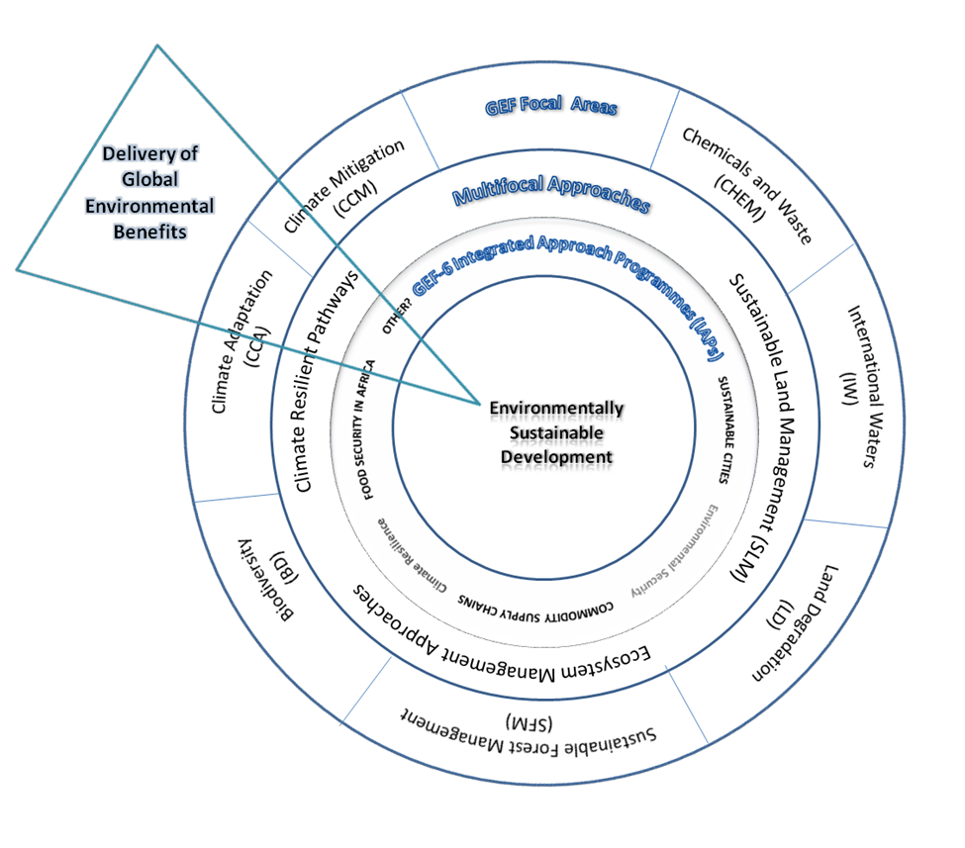

OPS-5 Findings

3. The STAP evaluation of OPS-5 acknowledged that “STAP remains a useful and respected body that has made substantial contributions to the functioning of the GEF and great strides since its inception and subsequent alterations”. The report also identified a number of important deficiencies and necessary improvements for STAP’s business model and its activities, which should be viewed within the context of the above overall OPS5 conclusions. The following key findings from the STAP evaluation are especially pertinent:

- STAP has to further increase its strategic contributions and enhance its visibility. STAP should refocus its activities on identifying the critical pressure points within distressed natural systems and therefore help GEF identify where interventions can achieve most global benefits in accordance with the GEF’s overall mandate. Given limited STAP resources, this recommendation calls on shifting STAP’s work more towards strategic, long-term issues facing the global environment, and away, in part, from its current main role in providing scientific and technical quality control of GEF projects.

- STAP should take a stronger role in “defining” and “supporting” science in the GEF. Achieving consensus across the GEF partnership with clear definitions and using scientific evidence where appropriate within the GEF may be a challenging role for STAP, but could increase the importance of better recognizing science in the GEF Program and improve the impact of STAP’s work. This recommendation also calls on the enhanced leadership role of STAP in establishing and supporting GEF knowledge management systems, including a specific role for the STAP in revitalizing the role of research in the GEF Program.

STAP Self-Assessment

4. Analysis of STAP’s activities over the last 8 years (GEF-4 and 5) reveals that the majority of STAP’s programmatic activities addressed specific focal area requests, only occasionally tackling higher-level strategic issues facing the GEF partnership. While calling for increased integration between GEF focal areas, and supporting the shift towards transforming the GEF into an evidence-based knowledge institution, STAP’s outputs and products in GEF-4 and GEF-5 would indicate that its efforts, while substantial, were largely a reflection of the existing GEF focal area “silos” (i.e. delivering results largely within the outer ring in Figure 1).

Examples of specific focal area results, largely well received by the GEF partnership, include numerous products such as: The evidence base for community forest management as a mechanism for supplying global environmental benefits and improving local welfare (STAP 2010); Environmental certification and Global Environment Facility (STAP, 2010); Hypoxia and nutrient reduction in the coastal zone (STAP, 2011); GEF Guidance on emerging chemicals management issues in developing countries and CEIT (STAP, 2012); Managing soil organic carbon for global benefits: A STAP technical report (Govers et al., 2013); and Climate change: Scientific assessment for the GEF (STAP, 2012).

In a few instances, STAP ventured into addressing higher-level strategic issues of greater complexity and operational relevance for the GEF. Examples of this work include: STAP’s advice on Experimental Project Designs in the GEF (STAP, 2012); Marine Spatial Planning in the Context of the Convention on Biological Diversity (STAP, 2012); Marine Debris as a Global Environmental Problem (STAP, 2011); and STAP’s advice on climate resilience (GEF/C.39/Inf.18). Moreover, as a contribution to the start of the GEF-6 Replenishment process, in early 2013 the STAP produced a paper that helped to open the dialogue for explicitly considering cross-focal integration as part of the GEF-6 planning process.

In light of the above, it may be opportune for STAP to shift effort towards having a greater impact at the strategic level – i.e. the inner circles of Figure 1. If this novel approach is endorsed by the GEF partnership, it should be recognized that these changes will also have consequences for STAP’s business model and operational framework.

Proposed role for STAP in GEF-6

5. The evolution of STAP’s activities from the existing status quo, focused on focal-area driven scientific and technical advice, towards a more strategic approach would require focusing on a limited number of inter-connected strategic areas or work packages. In addition, a much closer interaction would be needed between the STAP and the GEF partnership as well as with outside scientific and technical communities. Drawing from the above analysis and the findings of OPS-5, Figure 2 organizes STAP engagement in GEF-6 into four main strategic areas. This document provides further details about three out of the four areas. The fourth area, relating STAP’s role in the GEF project cycle (depicted as “Project Cycle Operational Support”) is detailed in a separate document.

Figure 2: Proposed Role for STAP in GEF-6

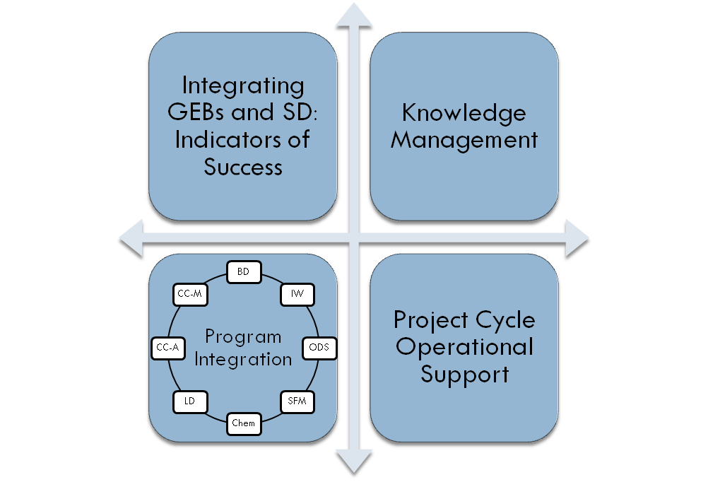
6. Connecting GEB’s and Sustainable Development: The aim of the GEF RBM system is to “improve management effectiveness and accountability by defining realistic expected results and targets, monitoring progress toward the achievement of the expected results and targets, integrating lessons learned into management decisions, and reporting on performance”. The GEF RBM works at different levels, from projects to focal areas to the GEF portfolio level, and involves all members of the GEF family (GEF Council, GEF Secretariat, GEF EO, STAP, GEF agencies).
Indicators of Success: STAP’s specific role in this area could include technical support to the GEF partnership assisting in the development of a set of cross-focal area indicators that would reflect the increasing integrated nature of GEF Programs and ensure their alignment with the emerging sustainable development goals (post-2015 SDGs). This work can only be accomplished in close collaboration between STAP and all stakeholders within the GEF.

OPS-5 concluded that the existing GEF RBM is “a delaying factor” in the evolution of the GEF business model, a situation which has worsened incrementally through successive replenishments. Current best practice in global partnership programs indicate that there should be no more than 5 to 10 “easily measured outcome indicators for which data are readily available”. The existing GEF RBM now consists of about 616 elements in 11 inconsistent categories, with approximately 180 indicators. It is therefore clear that the GEF needs urgent reform of its RBM system which currently drains the technical, financial, and human resources of the partnership in trying to operate within the current RBM framework. Concomitantly, the RBM framework must also ensure recognition of meet sustainable development goals in parallel with GEBs.

STAP has providing advice to the GEF Partnership on a number of issues pertaining to RBM, including advising on focal area tracking tools and working with the Conventions to strengthen impact indicators and their links to the focal area results-based management. This advice should be continued as program integration evolves.

7. Knowledge Management: Starting in GEF-6, STAP should play a more strategic role in assisting the transformation of the GEF into a more evidence and knowledge-based institution. OPS-5 underscored the unfinished nature of the GEF KM systems that STAP contributed to developing with other GEF partners (GEF-5 KM Initiative - KMI) over the last several years. Assessment of the existing GEF KM systems revealed that the GEF’s comparative advantage lies at the portfolio and regional/global levels. Knowledge systems should emphasize content creation based on portfolio analyses, and focus on global environmental benefits and impacts, through collaboration across the network of GEF partner agencies. The emerging consensus on the future of GEF KM suggests that the GEF should build on the existing technical and operational knowledge of GEF agencies and other stakeholders. A second key element of transforming the GEF into a more evidence and knowledge-based institution is through approaches that more strongly connect science and implementation, such as embedding experimental design into GEF projects to test hypothesis regarding effectiveness of interventions, or targeted research, which is a means for generating knowledge that can directly support design and implementation of interventions. These are areas that fall naturally within STAP’s mandate, and may warrant greater emphasis during GEF-6.
KM: In addition to STAP’s strategic role in helping to shape the knowledge systems of the GEF, its comparative advantage in generating specific KM products includes the following elements:
- Targeting research and analysis at the portfolio level to address key knowledge gaps in the GEF program;
- Thoughtful use of experimental project and program design approaches to answer specific questions and address untested assumptions in the GEF Program;
- Leveraging the knowledge base from the existing repository of GEF projects;
- Contributing to knowledge exchange platforms, learning networks, and communities of practice through facilitating greater involvement of outside scientific partners in areas of strategic importance for the GEF.

8. Program integration: As noted above, identifying new areas for cross-focal area integration represents a growing area of STAP’s work. This builds on important demand-driven activities within focal areas, addressing challenges which transcend traditional focal area boundaries with potentially longer-term impact on the GEF and engagement of stakeholders beyond the traditional GEF partnership including the broader scientific community. Where possible, STAP’s work in this area should be expanded and aligned with the evolving GEF Integrated Approaches and KM strategy. It is proposed that STAP take on a smaller number of higher profile assessments/advisory products of a more integrated nature, of both practical and scientific relevance that would advance GEF’s programming beyond GEF-6 (i.e. towards the inner circle of Figure 1). These areas should be defined at the beginning of GEF-6 and pursued throughout the next four years in preparation for GEF-7. One suggestion is that this work should focus largely on addressing the scientific underpinnings of the Integrated Approaches of the GEF-6.
Program Integration: A number of areas are emerging as potential candidates for STAP’s scientific and integrative work, including: (i) resilience of socio-ecological systems to climate change, (ii) food security, (iii) commodity supply chains and environmental degradation, (iv) sustainable cities, (v) black carbon, and (vi) environmental security. Each area of program integration, as with all STAP activities, would include a results framework with specific objectives and deliverables. It is expected these activities would entail higher levels of collaboration amongst Panel Members and longer time periods to complete.

9. Project cycle operational support. Please refer to the paper “Discussion Brief: Proposed Changes to STAP’s Role in the GEF Project Cycle”.

STAP’s business model

10. While STAP’s lean structure consisting of seven part-time global expert advisors and a small Secretariat should be preserved, the working modalities of the Panel and its Secretariat will need to need to evolve in order to successfully execute the role proposed in this paper. For example, the Panel’s working arrangements could shift towards small teams focused on specific themes such as those shown in the areas outlined in Figure 2. Each team would be convened by a Panel Member with support from the Secretariat and would integrate stakeholders from the GEF Partnership. These working groups could include external experts, permitting greater flexibility and opportunities for engagement with the broader scientific community. Depending on the nature of certain products, STAP could envision engaging respected global institutions that could lend expertise to the delivery of some of STAP’s program. Working groups or teams would be formed where needed with specific terms of reference and timeframes. STAP will, of course, continue to be responsive to the needs of the focal areas, even as it supports greater integration across focal areas.

11. The STAP work program should be complemented by a strengthened STAP communication strategy and, should funding permit, the employment of a professional to oversee and support this work in the Secretariat. A clear communications strategy, along with professional support, will greatly assist outreach and dissemination efforts within the GEF Partnership including outside audiences and could significantly contribute to ensuring STAP advice helps guide future GEF funded initiatives. This should also assist in connecting the GEF’s work more effectively to external scientific and policy networks, thereby enhancing its role as an innovator and knowledge leader.

http://www.thegef.org/gef/sites/thegef.org/files/documents/GEF.R.6.Inf_.03_STAP%20Paper.pdf Enhancing the GEF’s Contribution to Sustainable Development
http://www.stapgef.org/delivering-global-environmental-benefits-for-sustainable-development-report-to-the-5th-gef-assembly/

